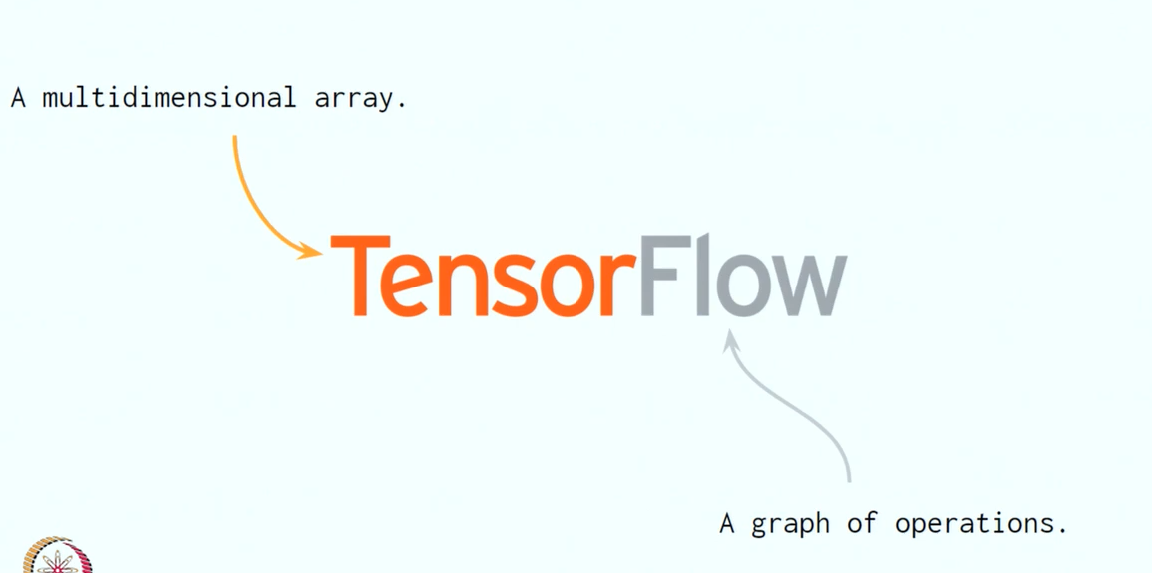
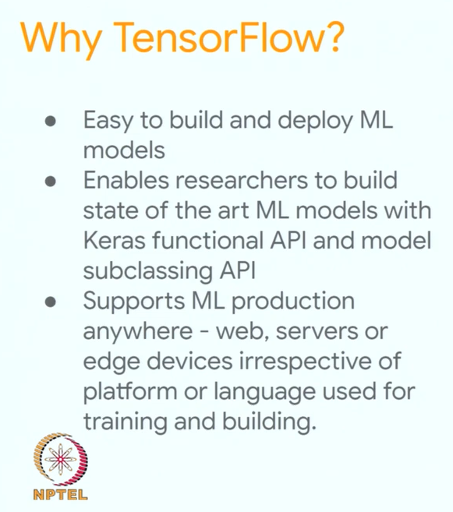
Example:
Emnist dataset has grayscale images of handwritten image. Each image is 28px*28px and tagged with the label of actual number it is present in.

#Enables easy deployment across various platforms such as GPU,TPU,CPU.

https://www.saedsayad.com/
Difference between programming and machine learning.

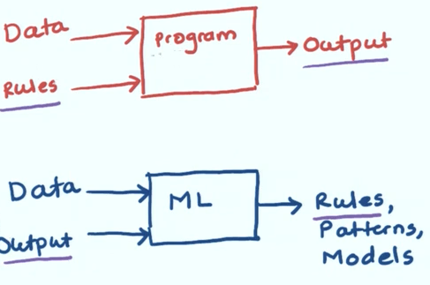
Programming

Machine Learning

How machine learning works.

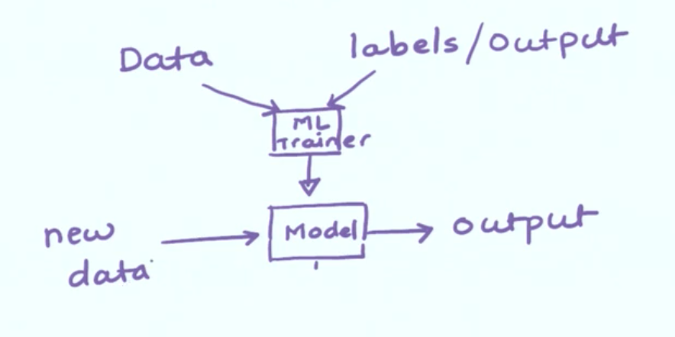

Breaking down the structure.

ML model is given input features with corresponding output upon which it is trained later different set of data values are passed to it to predict a output.

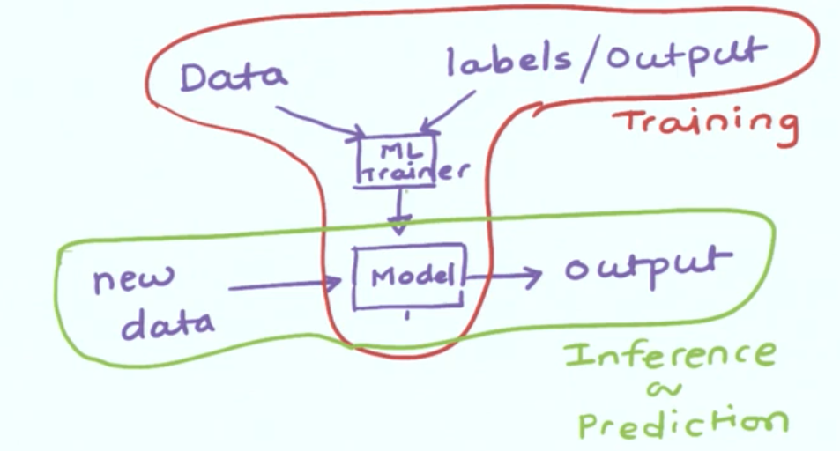

Different types of data.

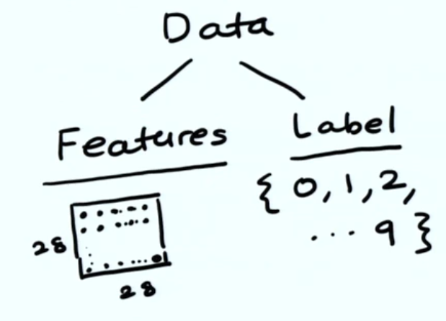
1) Features --> The test input data provided
Eg. Different 28px*28px images provided which are to be recognized.
2) Label --> The answer that should be resulted
Eg. Different class of numbers {1,2,...9} that the given image should be categorized into.

Thus for n different values data can be written as a collection of Features and Labels.
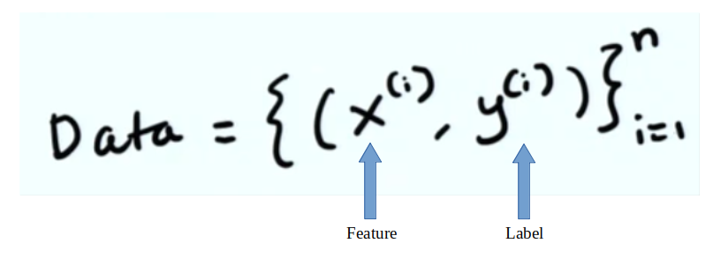

Different types of Label.

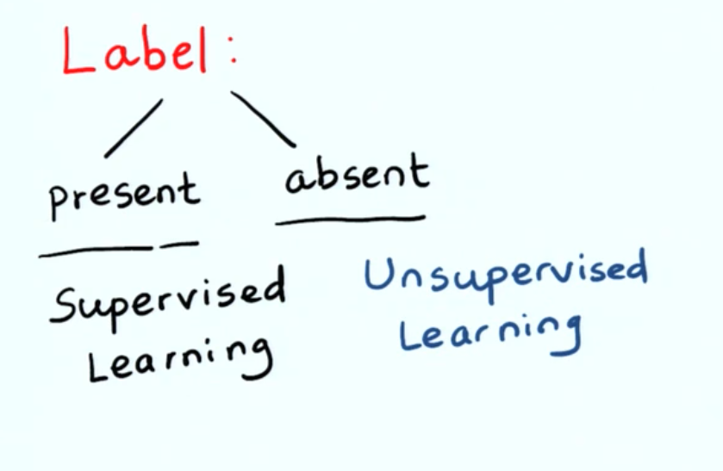
1) Supervised Learning:: If label/output is present corresponding to the data/features.

2) Unsupervised Learning:: If label/output is not present corresponding to the data/features.

Labels are of two types.
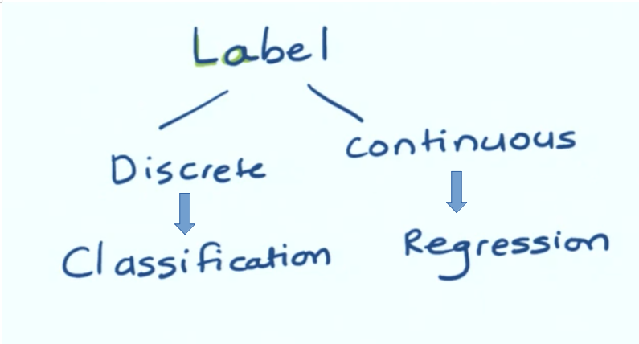
1) Discreate – They are solved with classification.
Eg. Classifying a answer into ‘Yes’ or ‘No’. Here yes/no are two categories.
2) Continuous – They are solved with regression.
Eg. That cannot be classified into categories and are continous in number like age.

Feature is of two types.

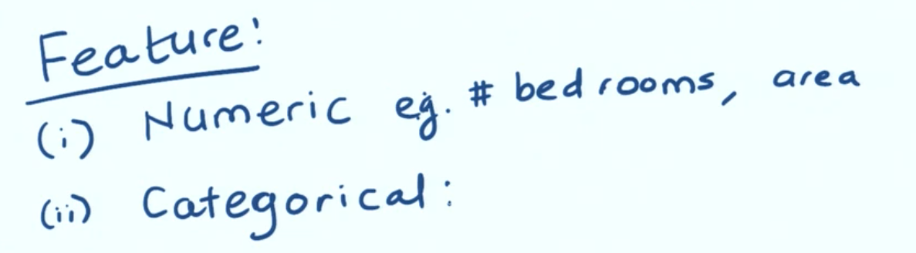
In case of house price classification problem.
1) Numerical Features: number of bedrooms, area of bedrooms.
2) Categorical: In which state is the house located Mumbai, Delhi, Chennai etc.

****For processing purposes data should always be numeric.****

***When exploring univariate data it can be of two types numerical and categorical. Numerical data can be converted to categorical data by binning. And categorical data can be converted to numeric data using Encoding. ***

Converting categorical data to numeric data.
Method 1: One-hot-encoding.
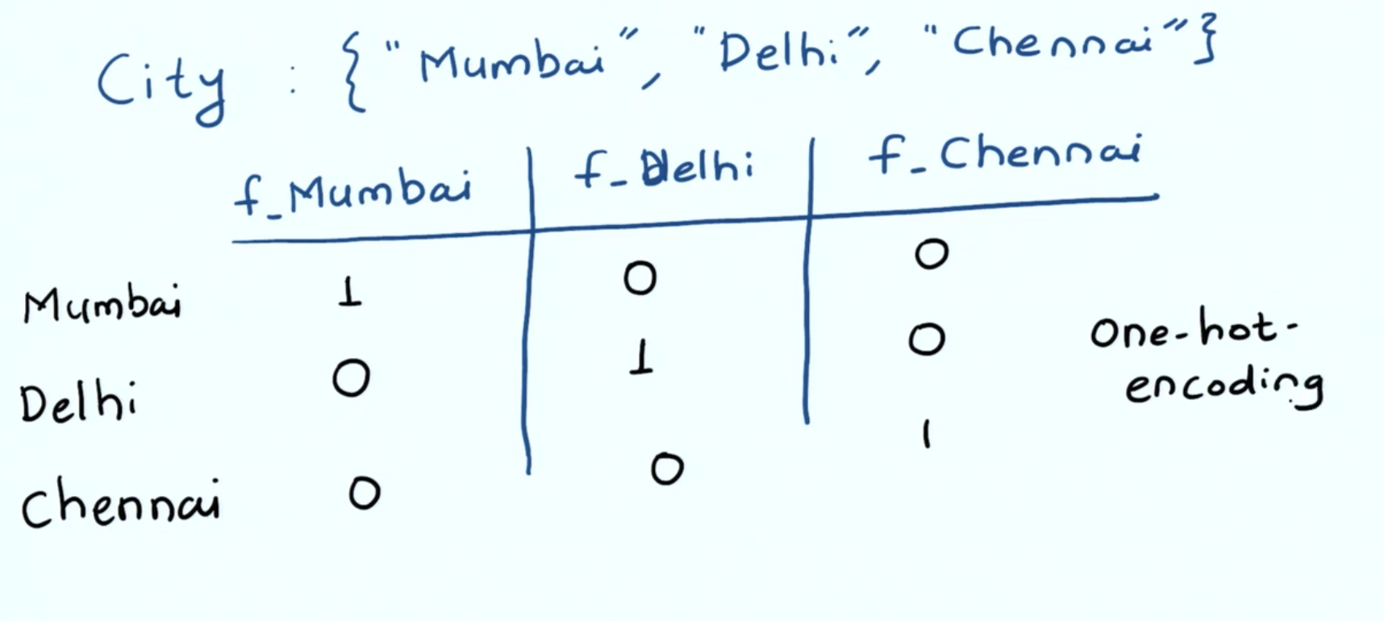
Other Methods:: Using groupby command.

Converting numerical data to categorical data.
Method 1: Binning.
CODE Eg. pd.cut(data[‘Fare’],bins=4).value_counts().plot(kind=’bar’)
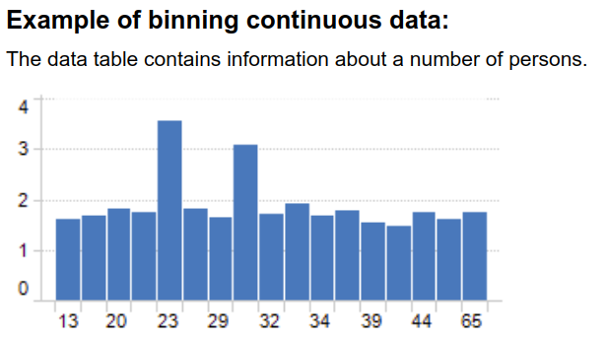

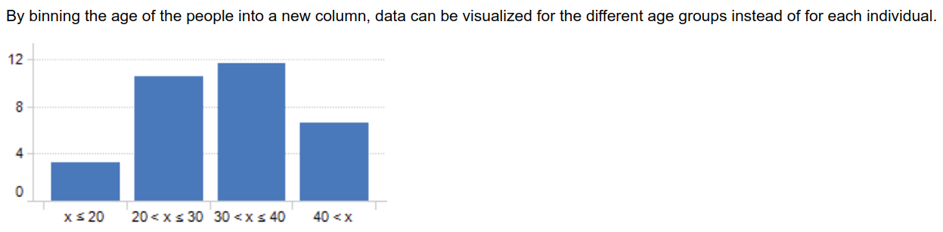

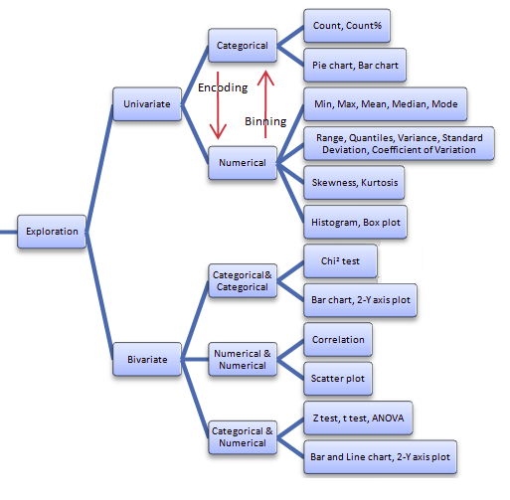

STEPS OF MACHINE LEARNING:::
https://www.geeksforgeeks.org/data-preprocessing-in-data-mining/
1)
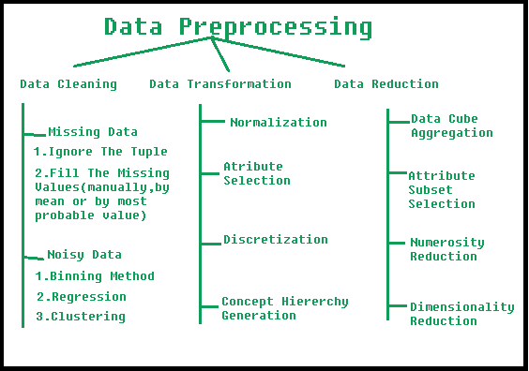
1) Data preprocessing. We remove incosistency and remove outliers to maintain high quality of data.
Eg. scales of all features should be same. So we normalize the features, using diffenent techniques
like Z-Score Normalization, min-max normalization or transformations like log transformation or square root transformtion.
Z-Score Normalization: Gives distance of the point wrt mean in terms of the standard deviation.
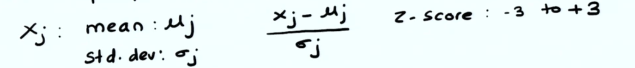
Min-max:
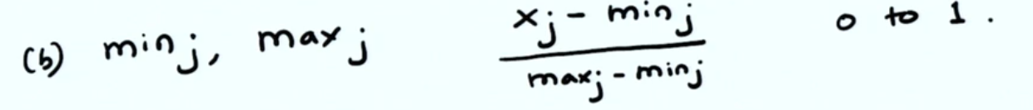
2)
Data Vizualization

3)
Model Building

Expanding on Data-Normalization for data preprocessing.
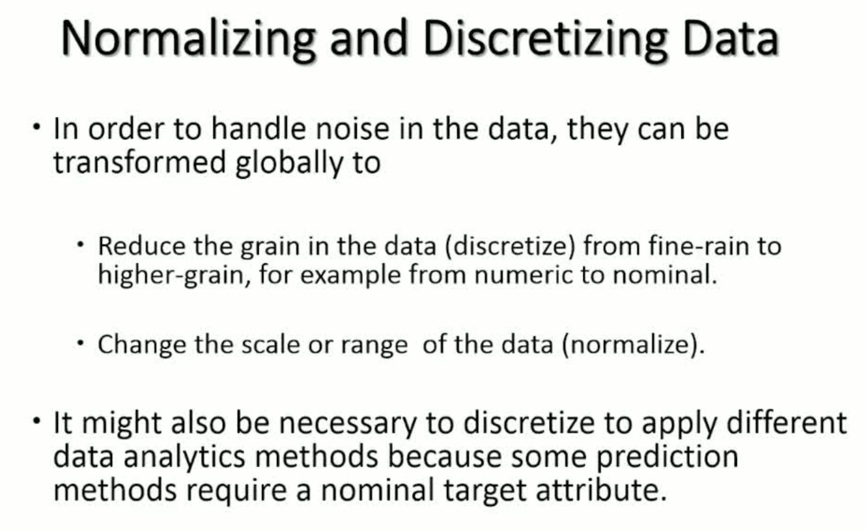

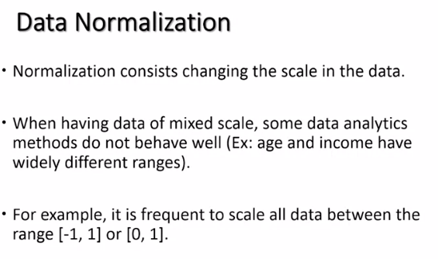

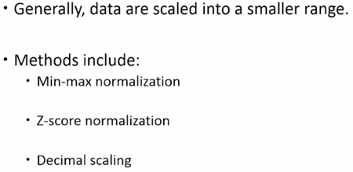

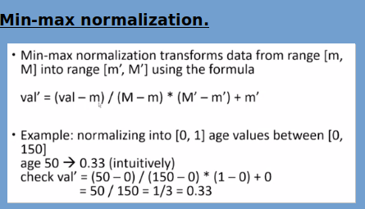

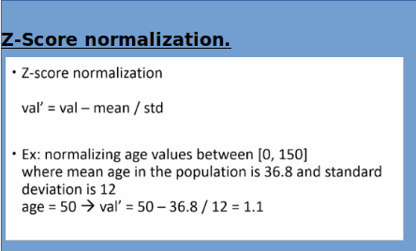

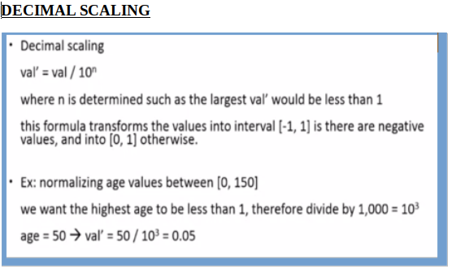

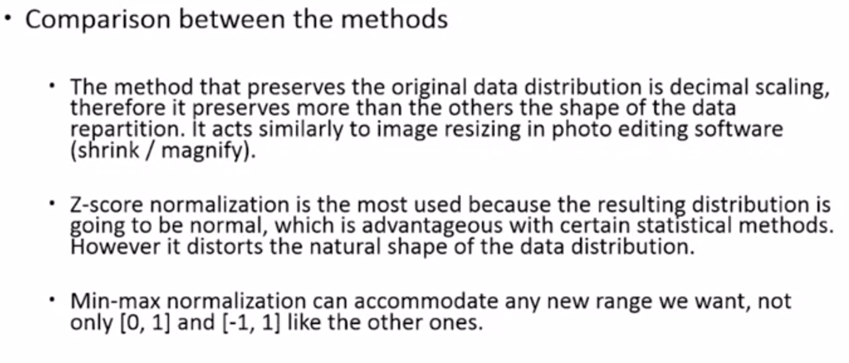

Linear Regression Model.
Used for prediction of continous(numerical output)

1) With single paramter.
Eqn. Of a line,
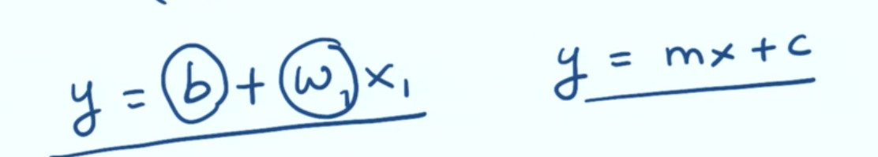

2) With multiple paramters
Suppose we have M features(x) and parameters(w).
Eqn of a plane
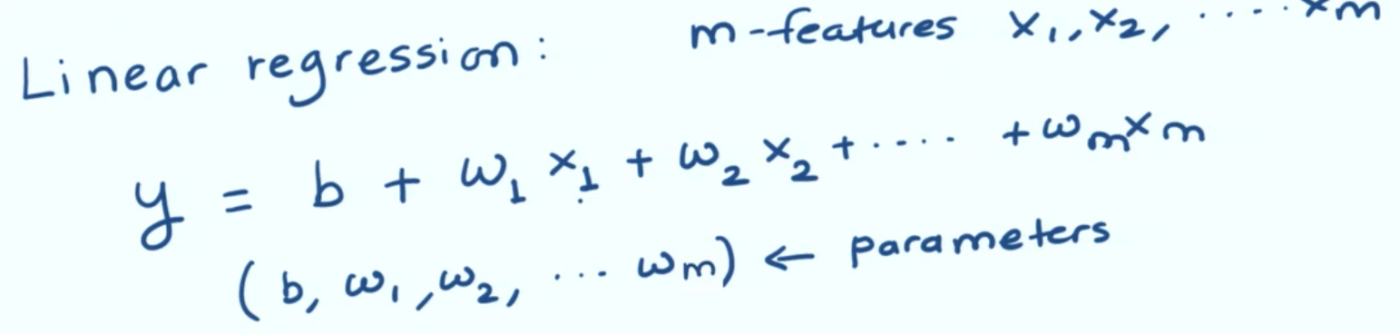

Diag.
X--> Features. Y--> Label.
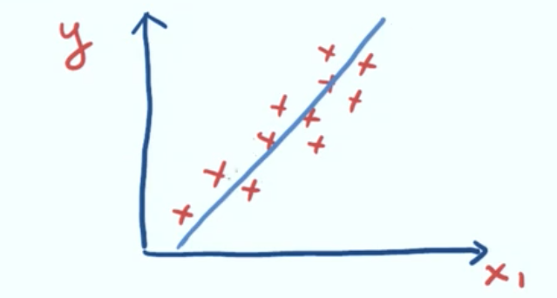

SIGMOID FUNCTION
It takes a real number and passes it to a sigmoid()function that squashes the number b/w 0-1.
It crosses the y-axis exactly at 0.5.
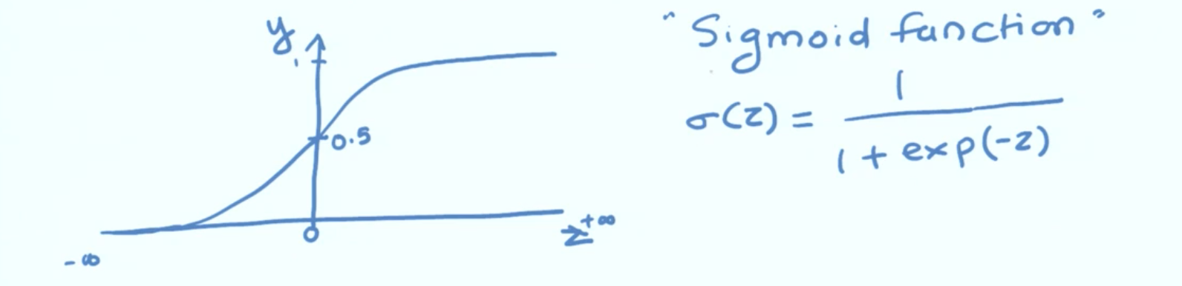
{ Here, sigmoid(Z)=(z)}

As it is clear from the diagram:-
* Z=0 ------> (z)=0.5
* Z moves to + ------> (z) tends to 1.
* Z moves to - ------> (z) tends to 1.

Logistic regression
Used for prediction of categorical output.

Given this real number. Task is to convert it into descrete quantity(between 0 to 1).
Solution:: Logistic Function.

So, by applying z to the sigmoid function we get.
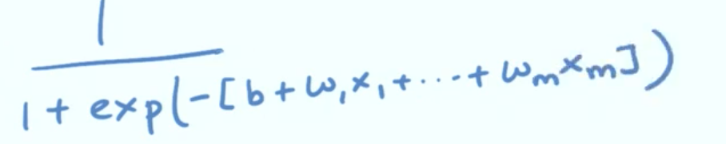

In the most basic case what logistic regression is used to seperate two classes.
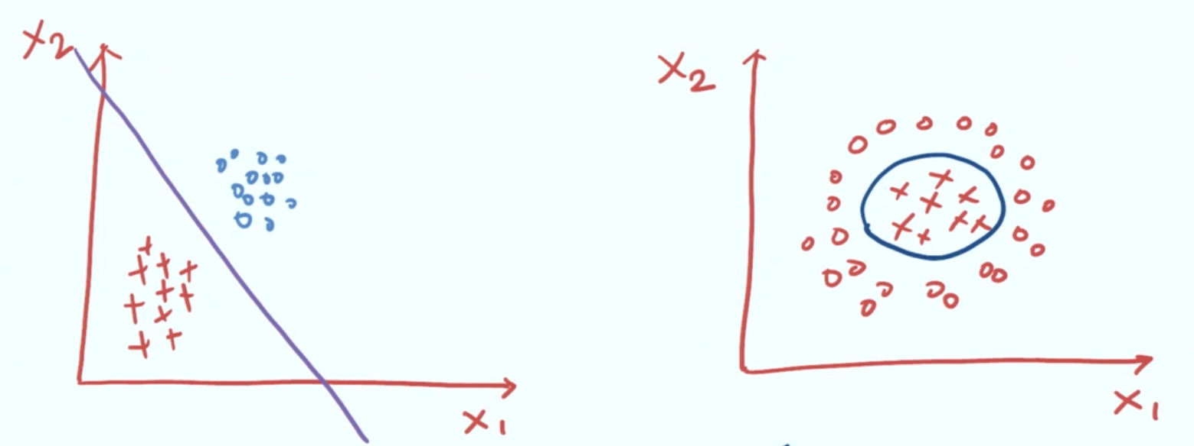
In case 1:
The two classes are easily seprable.

In case 2:
The two classes are not easily seprable.

In case 2 of the above figure much complicated mathematics is involved behind making the seperator
This is where Neural Network comes into picture.

Neural network is the mechanism to construct complex functions by composing simpler functions.

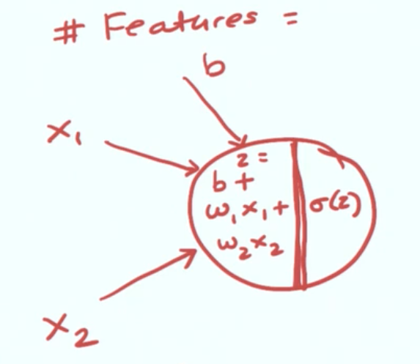

Inputs:
*) Above fig. Represents a single unit of a neural network.
*) Two or more features are passed to this neuron.
*) A bias is passed to each neuron.
Components:
*) The inner components perform tasks upon the given features.
*) One part performs a linear combination part of the activation function
*) Another part performs the non-linear activaiton part where functions like RELU is applied.

Note: Y=b+w1X
b -> intersept. OR parameter
w1 -> slope. OR parameters.
X -> axis/independent fields OR features.
If we change the model parameters(m/slope) we change how the line looks.
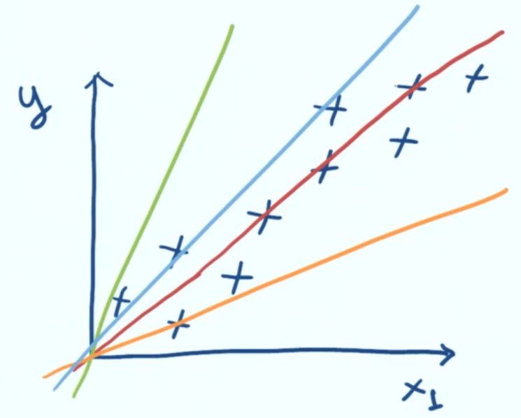

#Each colored line shows a different feature.

LOSS:
It is the difference between the prediction at that point and actual value.

LOSS FUNCTIONS:
We use loss function as a tool to determine which above line suits the model. This is done by estimating the model parameter.
It helps us to identify the model parameters such that the loss is minimum.
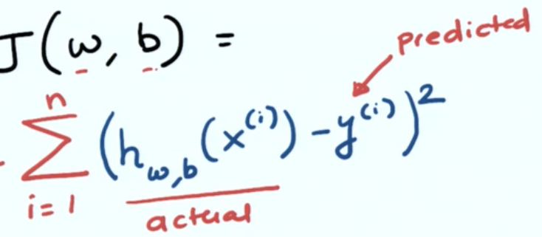

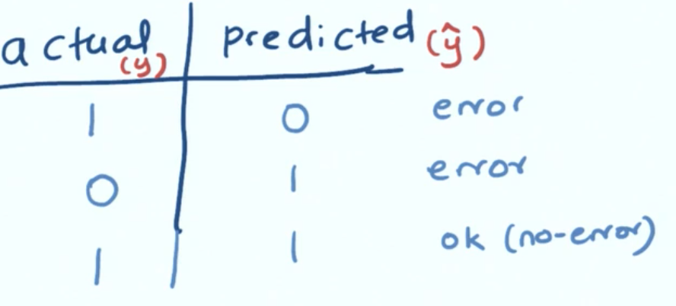

*This fig. Shows the different values of actual and predicting variables that result in an error.

Loss function in case of Linear Regression
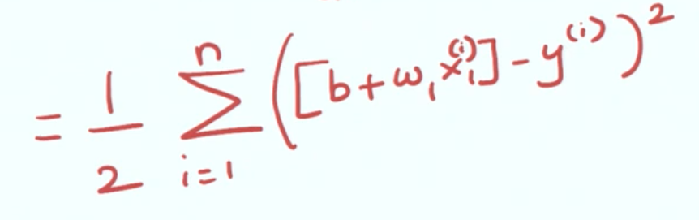

The above technique is called the MSE
OTHER METHODS: absolute loss, SME.

Loss function in case of Logistic Regression(classification)
If actual value of y is zero and you predict 1 penalty is very large.
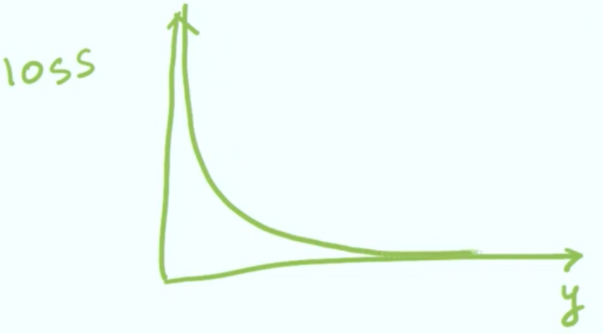

Similarlty is actual value of y is one and you predict 1 penalty is very large.
Combining both cases we get.
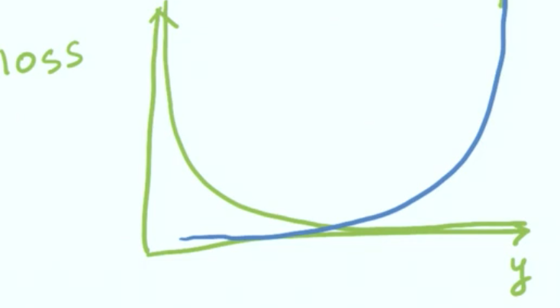

Presenting the above eq. Mathematically we get.
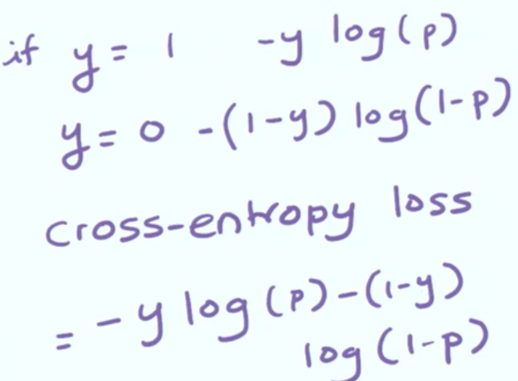

How to find the optimal value of paramters to minimise the loss.
Ans: Optimization algorithms.

*One of the important and most commonly used optimization algorithm is gradient descent.

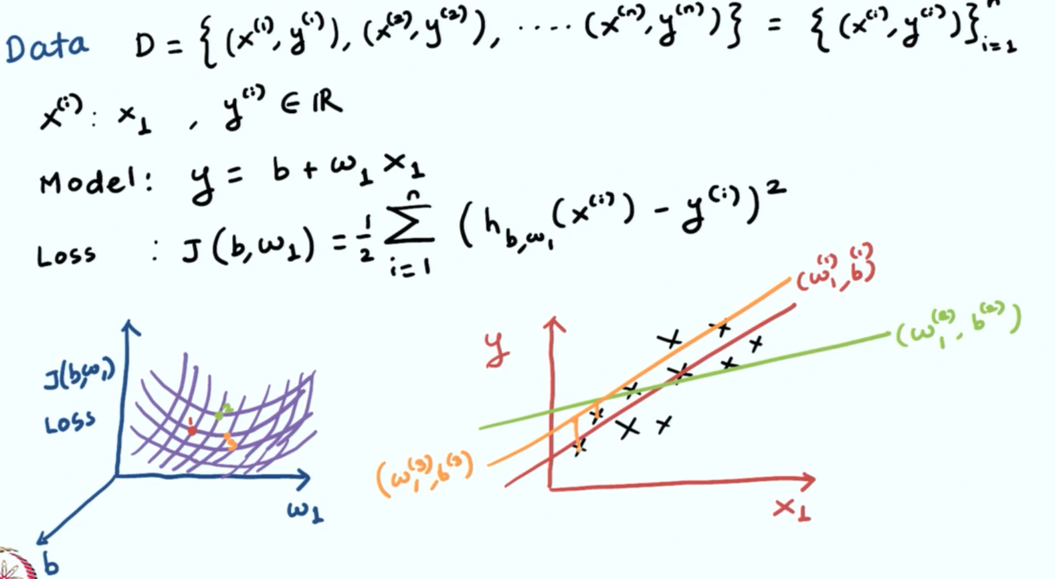
In the given above situation::
*) Data is of form (x,y) where x represents a feature and y is some real number corresponding to that feature so this problem becomes a linear problem in nature.
*) This model can be understood as a linear regression problem.
*) The loss function to calculate loss is given.
*) Each cross-section point in the left figure, which shows the loss space maps a different line, on the right figure that dipicts different models.

Objective: Is to find a model(values of w and b) in which loss is minimized.

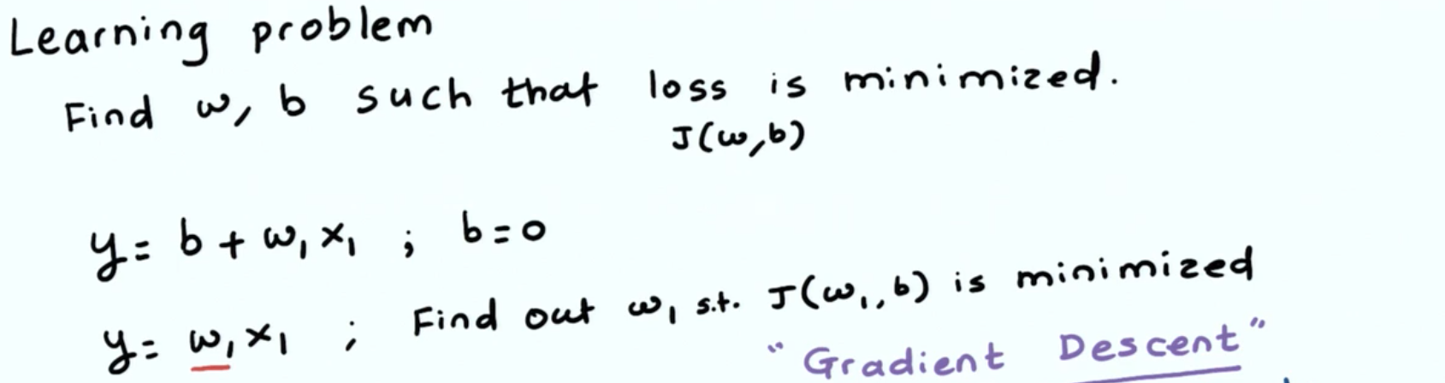
Step 1) We first initialize the a random value of w1(parameter)
Step 2) Using the given loss function we calculate the value of J(w1,b) i.e. loss
Step 3) Gradient can be considered as a slope at a given point. For the given curve of the loss function we keep on calculating the the gradient(Slope).
Step 4) We move in the opposite direction of the gradient. The intensity of our movement is determined by the learning rate.
Step 5) We keep on calculating the loss by repeating step 2 to step 4.
Step 6) At the minimum point the gradient becomes zero and we consider it to be the minima. This means that each iteration the length of the stride becomes shorter.
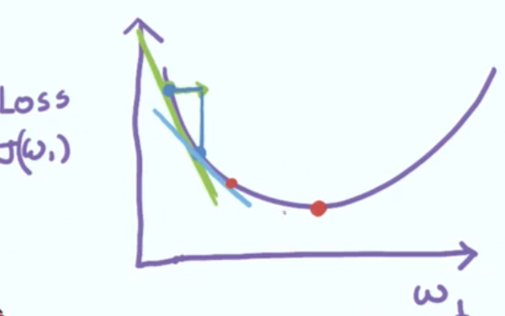
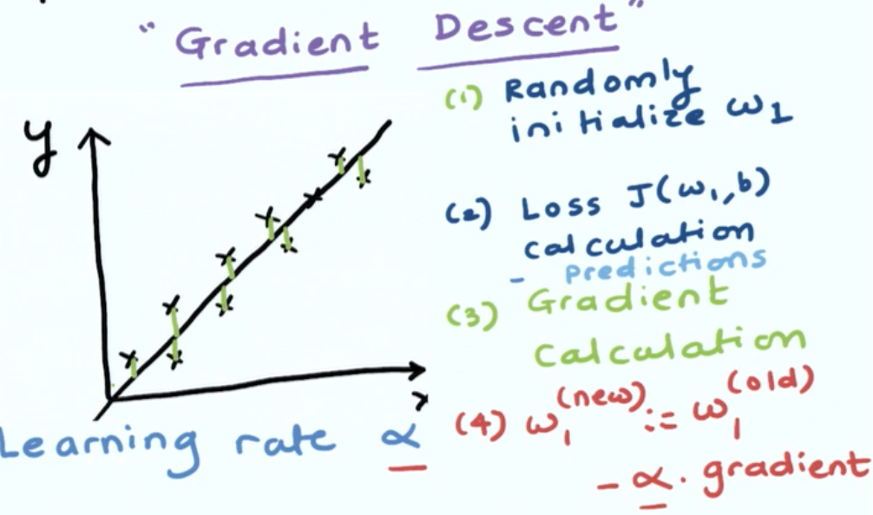

<-- This shows the loss function line wrt Linear Regression.

<---- Loss Space.

<--- Model Space

Generalizing the Gradient Descent for (m + 1) paramters [ +1 is for b]
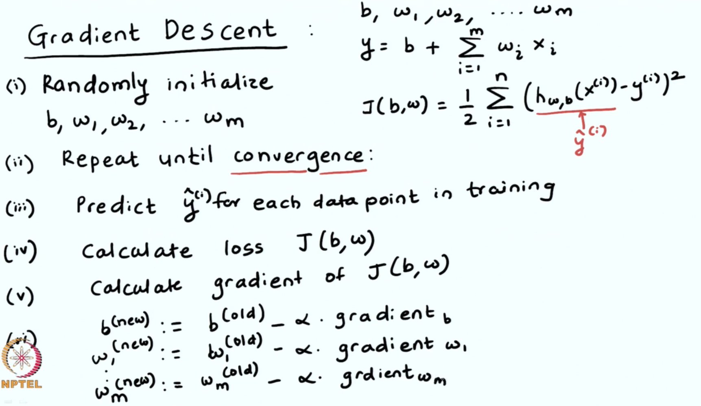
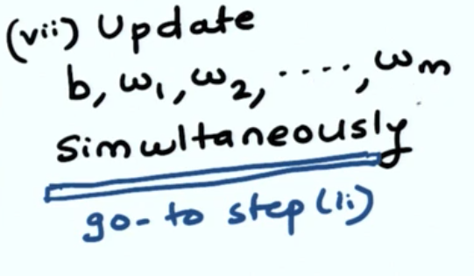

Epoch --> The number of times you give data to the neural network. More Epochs means overfit the data. Less Epoch means underfitting the data.

Different dataset used during training and testing a Neural Network.
Our primary data-set is broken into three different datasets.
1) Training set. 2) Validation set 3) Test set.

Training set-> set of data used to train the model. During each epoch our data would be trained repeatedly over the same data in our training set and will continue to make predections about our data.

Validation set-> data that is seperate from training set and is used to validate our model that is built during training. This gives us information that helps us to adjust our hyper paramters. After each epoch when data is being trained on the training set it is simultaneousy be validated in our validation set.

##After the classification is done the loss and the loss is calculated and the weights in the model will be adjusted. In the next epoch it will classify over the same input again.

Test set --> It used to test the data after the model is already been trained. This is diff from both training and validation set.

##THE TEST SET IS UNLABELLED WHILE THE TRAINING AND VALIDATION SET ARE LABELLED.##

Gradient Descent Variations.

Techniques of Model Evaluation/Model Selection.
How well the model will work on the unseen data and future data.

Assumption:: Training and test data should come from the same distribution.

Question: “How do we estimate the performance of a machine learning model?”
Answer: “First, we feed the training data to our learning algorithm to learn a model. Second, we predict the labels of our test set. Third, we count the number of wrong predictions on the test dataset to compute the model’s prediction accuracy.”

Evaluation measures in practice.

In case of regression
1) MSE (means square erorr)
2) MSB

In case of classification
After calculating the confusion matrix we use:
1) Precision
2) Recall
3) F-1 Score
4) Accuracy
5) ROC-curves

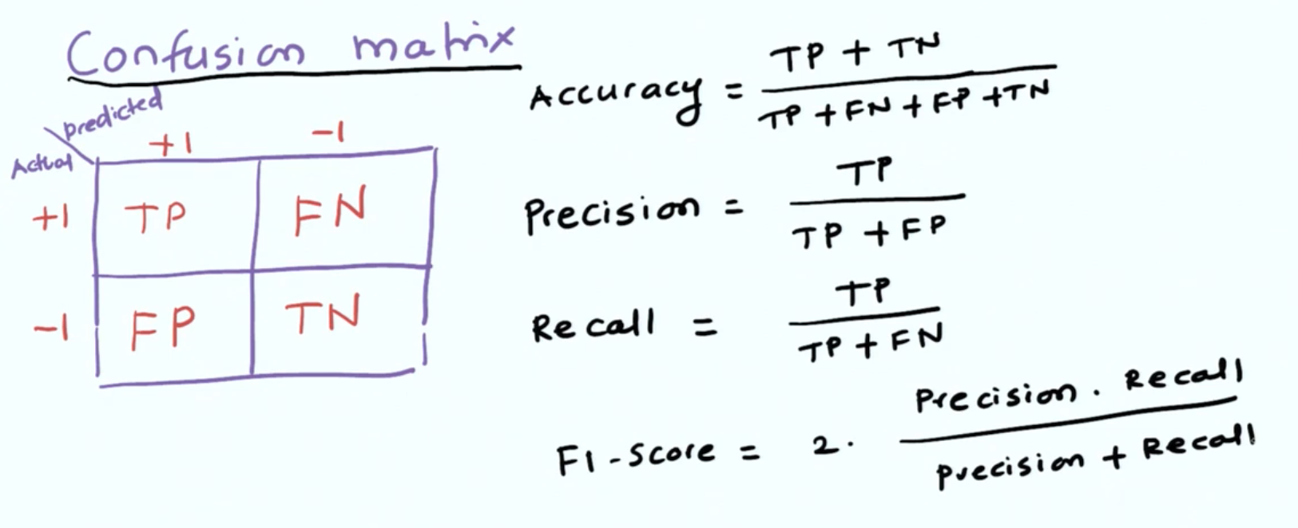

Underfitting and overfitting with the model.
After the training of the model three circumstances will arise.

Underfitting:: Model dosent take into account the training data and is going by a strong bias that what ever the input the output will remain constant which is a fixed number. Here model complexity is very low and has only one dimension.
Overfitting: You end up achieving zero error on the training data but the model may not generalize well on the future data. Here model has high complexity
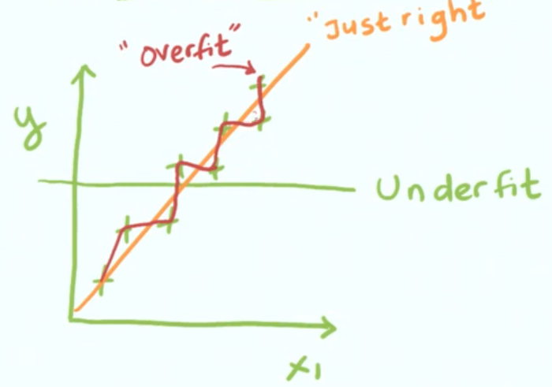
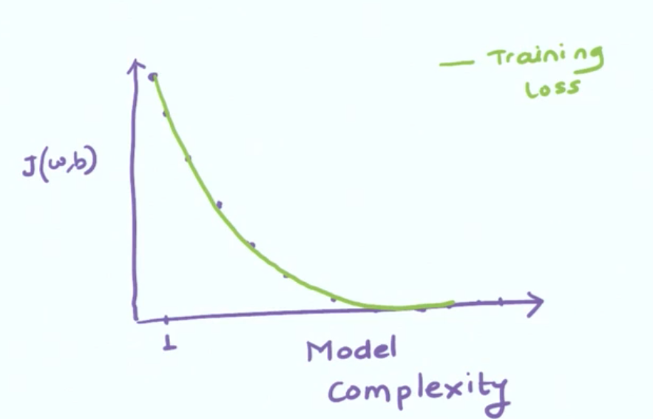

Loss increases as complexity decreases and vice versa.

Fixing Underfitting::

Increase complexity by adding more parameters:
1) By Increasing the number of features.
Eg. earlier features were x1,x2 now become x1,x2,x3,x4..

2) By Increasing the power of features.
Eg. earlier features were x1,x2 now become x1^2,x2^2.

3) By cross multiplication through multiplying the two features.
Eg. earlier features were x1,x2 now become x1x2 as single feature.

Fixing Overfitting::
1) Get more data, so we have larger number of parameters.
2) Reduce the complexity through:
(i) Regularization: Penalize the model for being excessively complex. Its types are L2 regularization, L1 regularization
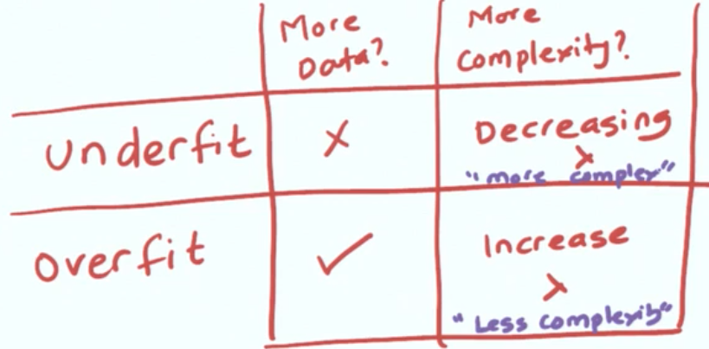

NOTE:: To the hist variable we pass the fit(). This represents history and stores all the accuracy during training of both validation and training data. So we can plot the graph from it.
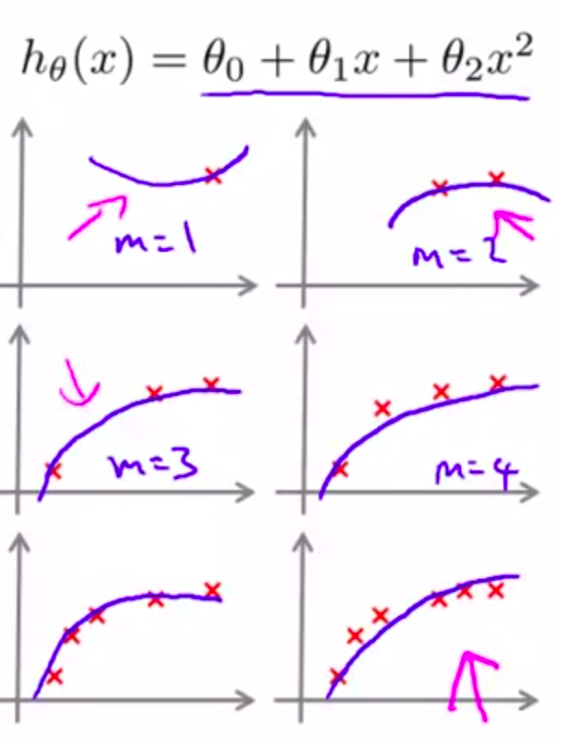
** if we have less number of data points in the training set and apply a quadratic model it fits perfectly and , the training loss is zero

**if we have more number of data points in the training set where a quadratic model is used to train the data, the training loss increases.

**But since our model is very well trained then the validation loss is decreased.

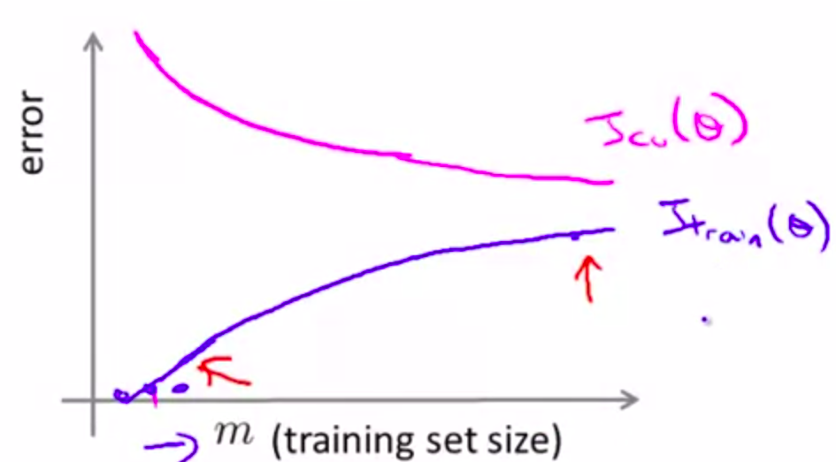

**The training loss increase as the data points increase and the validation loss decrease.

THROUGH COMMON SENSE:
* Cross-validation erorr[Validation loss] decrease when training set increase.
* Training error[Training loss] increase when training set increase

Overfitting:if: training loss < validation loss--- Means data is trained specifically to the given data set and model fits the data-set completely. Eg. If there is only one data point so training loss is zero.
Underfitting: if: training loss > validation loss--- As the data set size inc. Means model is trained better for more circumstances but however the same model cannot cover more data points in the in training set.
Just right: if training loss ~ validation loss

Final Flow Of Machine Learning
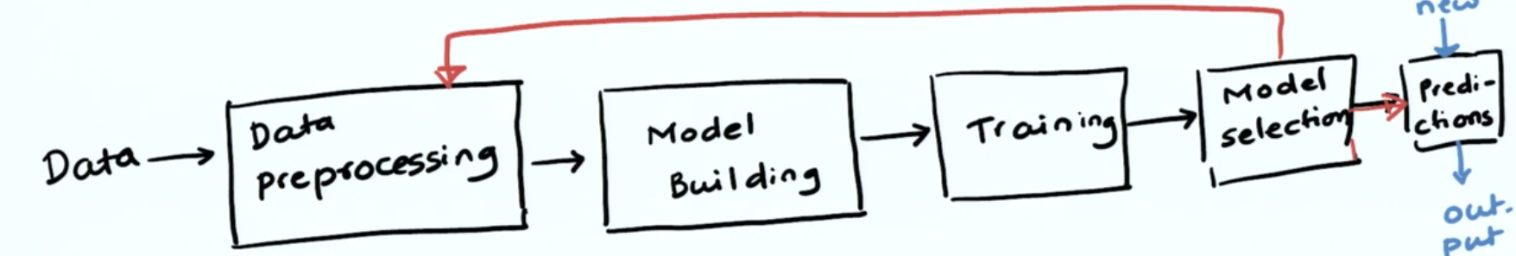
Data Preprocessing: It involves various process.
Model Training: we define a loss function and define the type of algorithm that we can use.
Model Selection: Selecting model of right complexity.
After model selection we could go back to the process of data preprocessing to add more features until model quality is satisfied.

Deep Learning.
Is used to learn representations of the data automatically without human intervension.

Representing Logistic Regression as Deep Learning.
m features has m nodes and a bias unit. The first unit called as input unit performs linear combination and results output say z. Second unit(called as hidden unit) has two parts. First part takes the z as input and performs a sigmoid activation function.
It applies logistic function on z and y is the result which can be interpreted as the probability of a example belonging to a class.
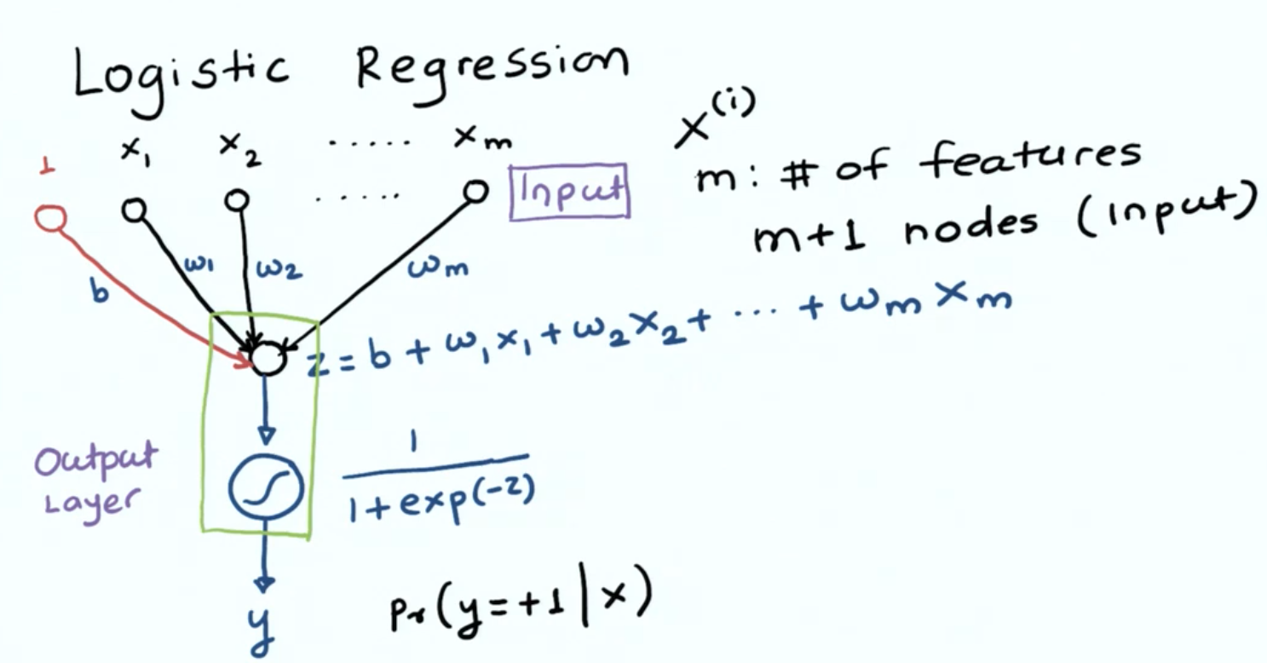
Representing Linear Regression as Deep Learning.
We have input layer which we have m features and a bias. All these inputs pass the result to the linear combination unit. This unit calculates the linear combination of features and their coeff./weights and results the output as z.
We pass the value of z through linear activation function and we get y as output.
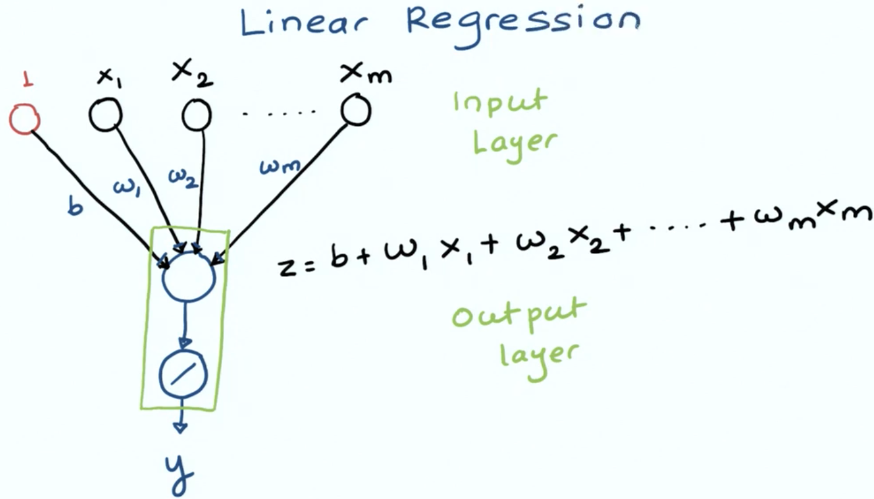

So, in the hidden layer first a linear regression is applied and the result of which is sent oto the non-linear activation functions.
These non-linear activation functions include.
1) Sigmoid
2) Relu
3) Tanh
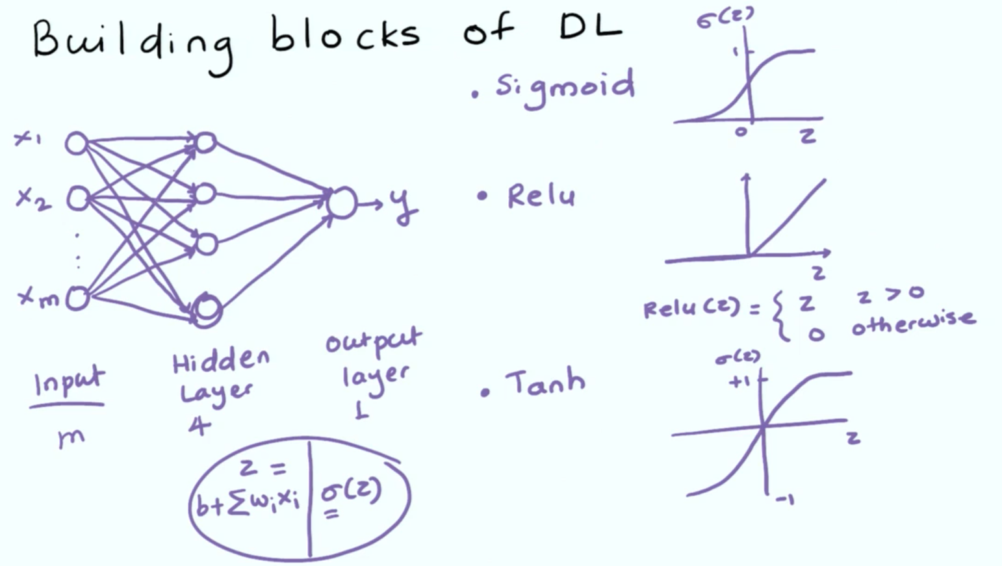
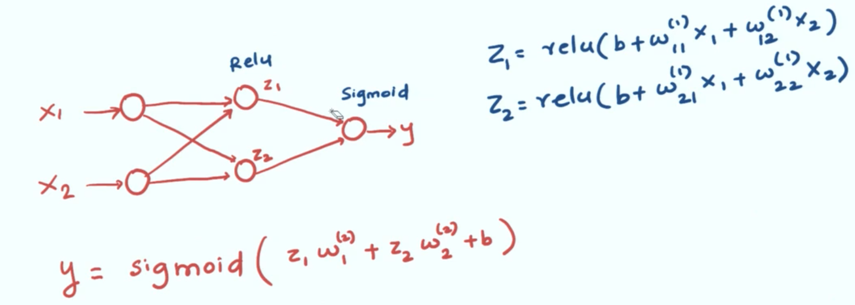

Architectures of NN.

FEED FORWARD NN.
Each unit of the previous unit is connected to the hidden layer.
It has multiple input layers.
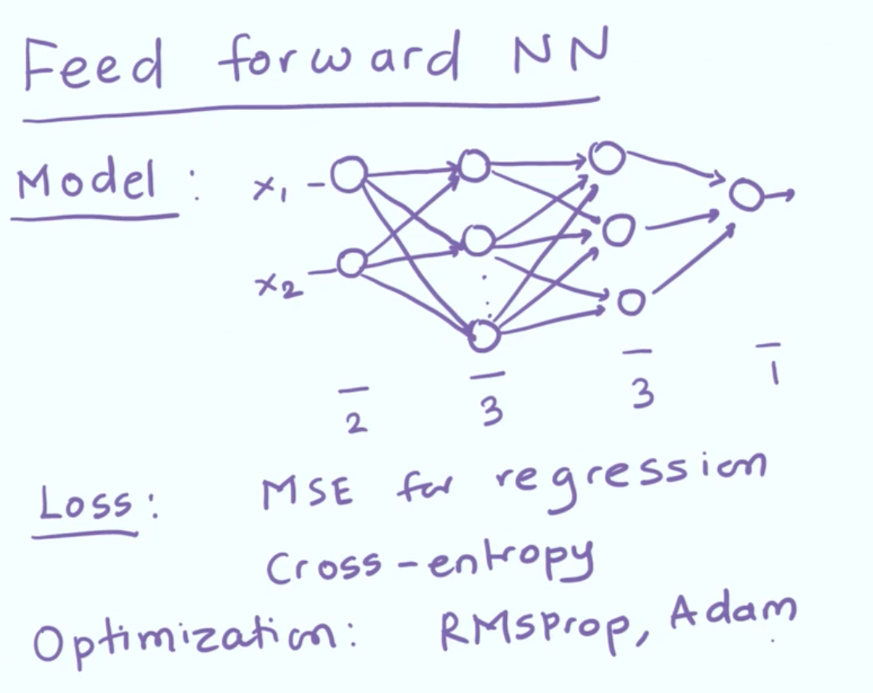

Tensor are multidimensional arrays. Tensor is a container for numerical data. Tensor is defined by three attributes.
1) Number of axes or rank(ndim)
2) Shape (shape)
3) Datatype (dtype)

Types Of Tensors.

*) SCALARS: A tensor that contain only one number is called 0-D or zero dimensional tensor or scalar.
eg. np.array(10).
So, shape ---- ()
ndim --- 0

*) VECTORS: A tensor that contains an array of numbers is called 1-D or one dimensional tensor or vector.
eg. np.array([4,5,6,7,9])
So, shape ---- (4,)
ndim --- 1

*) MATRICES: A tensor that contains 2 axes rows and columns. It is vector of vectors or 2-D vectors.
eg. np.array([1,2,4],
[1,4,6],
[3,3,9])
So, shape --- (3,3)
ndim --- 2
*) 3-D Tensors are tensors made when we pack matrices in an array(vector). Similarly we can pack 3D tensors in an array we can get 4D tensors and so on.
eg. np.array( [ [1,2,4],
[1,4,6],
[3,3,9]
],
[ [1,2,4],
[1,4,6],
[3,3,9]
],
[ [1,2,4],
[1,4,6],
[3,3,9]
])
So, shape --- (3,3,3)
ndim-- 3

Ques) What is tensor slicing.
Ans) It is the process of selecting single element or datapoint from the tensor.
x1=x_train[0] <-- will select the first image of x_train tensor.

